**Interpret image processing responses**

**Create and authenticate the client**

To authenticate against the Image Analysis service, you need a Computer Vision key and endpoint URL. This guide assumes that you've defined the environment variables VISION_KEY and VISION_ENDPOINT with your key and endpoint.

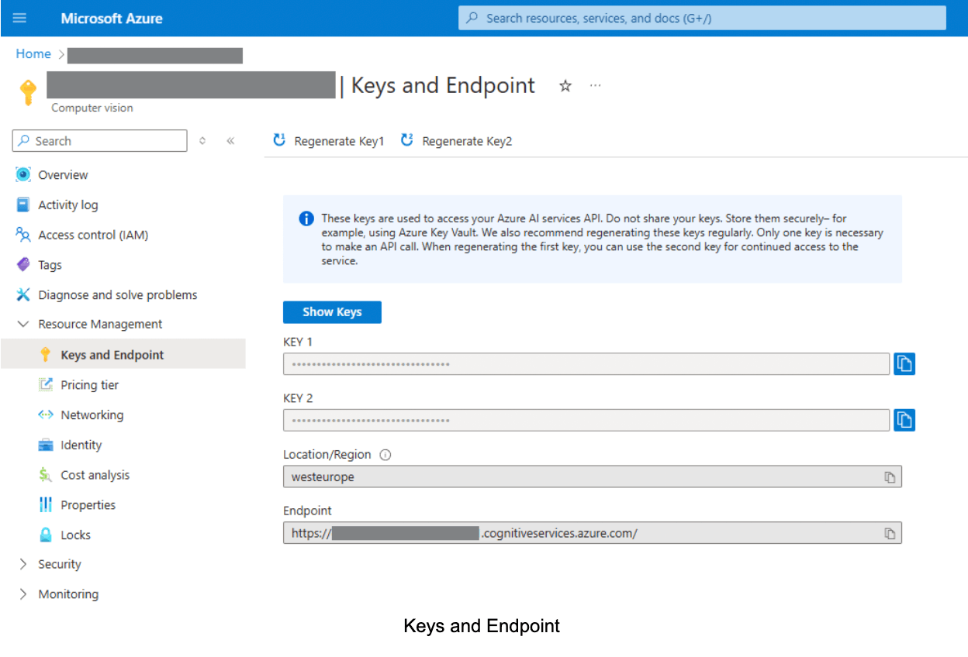

**Image URL**

Create a Uri object for the image you want to analyse.

**Select visual features**

The Analysis 4.0 API gives you access to all of the service's image analysis features. Choose which operations to do based on your own use case.

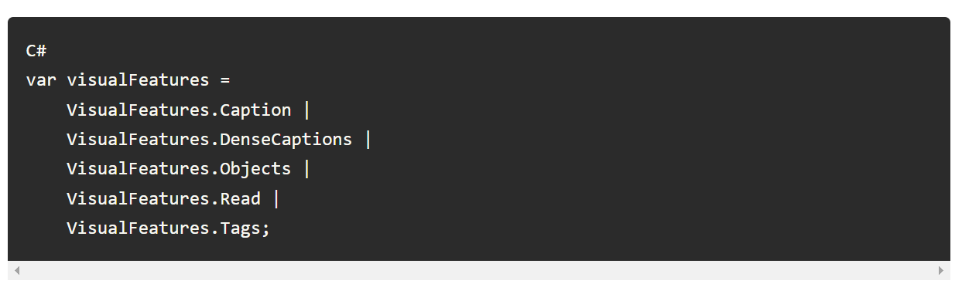

**Select analysis options**

Use an ImageAnalysisOptions object to specify various options for the Analyze Image API call.

* Language: You can specify the language of the returned data.
* Gender neutral captions: If you're extracting captions or dense captions (using VisualFeatures.Caption or VisualFeatures.DenseCaptions), you can ask for gender neutral captions. For example, in English, when you select gender neutral captions, terms like woman or man are replaced with person, and boy or girl are replaced with child.
* Crop aspect ratio: An aspect ratio is calculated by dividing the target crop width by the height. Supported values are from 0.75 to 1.8 (inclusive). Setting this property is only relevant when VisualFeatures.SmartCrops was selected as part of the visual feature list.

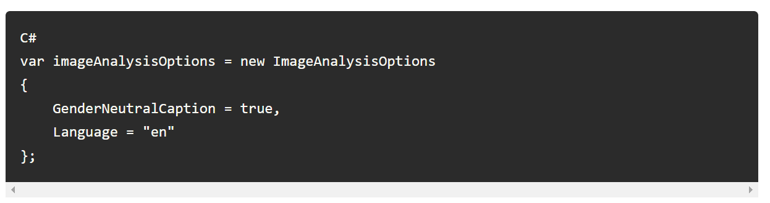

**Call the Analyze API**

Call the Analyze method on the ImageAnalysisClient object, as shown here. The call is synchronous, and blocks execution until the service returns the results or an error occurs.

**API Response**

The Analyze operation returns an **ImageAnalysisResult** object, which encapsulates a comprehensive set of visual data extracted from the input image. This rich dataset includes information pertaining to various visual attributes, such as captions, object detection, text and image tags.

Let's delve into the specific components of this response object to understand the insights it provides.

**Caption:**

The generated phrase that describes the content of the analyzed image along with confidence score.

**Dense Captions:**

Up to 10 generated phrases, the first describing the content of the whole image, and the others describing the content of different regions of the image along with a confidence score. Including bounding box size and coordinates on the image.

**Objects:**

A list of detected physical objects in the analyzed image along with confidence score, and their location.

**Read:**

The extracted printed or hand-written text in the analyzed image. Also known as OCR. Including confidence score and location.

**Metadata:**

Metadata associated with the analyzed image.

**Tags:**

A list of content tags in the analyzed image along with a confidence score.

**Confidence score**

A confidence score indicates probability by measuring the degree of statistical certainty that the extracted result is detected correctly. The estimated accuracy is calculated by running a few different combinations of the training data to predict the labeled values.

Field confidence indicates an estimated probability between 0 and 1 that the prediction is correct. For example, a confidence value of 0.95 (95%) indicates that the prediction is likely correct 19 out of 20 times. For scenarios where accuracy is critical, confidence can be used to determine whether to automatically accept the prediction or flag it for human review.

